
Update date, xx xxxx

Visa Debit Card Dispute Management
PROCESS

October 1, 2026

Document Tracking and Control Table

Policy Owner | TBC
Approval Date | TBC
Version | TBC
Access Level | TBC
Policy Author | TBC
Subject Matter Expert(s) | TBC
Last Full Review Date | TBC
Update Date (changes were made but a full review was not necessarily conducted) | TBC
Review Frequency Requirement | TBC
Changes made | TBC
Stakeholders Impacted | TBC

Purpose
The Visa Debit Card Dispute Management Procedure guides the Growth, Payment Services, Fraud Prevention, and Finance teams in managing member-initiated Visa Debit Card disputes. It sets out a consistent approach for receiving and triaging dispute claims, gathering and assessing supporting documentation, issuing provisional credit, submitting and managing disputes through Central 1 and the Visa network, and resolving disputes and recovering funds where applicable. It also covers the roles and systems involved, the process flows, and the detailed procedures across the dispute management lifecycle.

Scope
This procedure applies to all team members involved in the intake, triage, investigation, submission, and resolution of member-initiated Visa Debit Card disputes, received through the following channels:
- Branch: occurs when a member visits Beem’s branch to dispute a Visa Debit Card transaction.
- Contact Centre: occurs when a member contacts Beem’s Growth Team by phone to dispute a Visa Debit Card transaction.
This procedure covers the five stages of the dispute management lifecycle:
Stage 1. Dispute Intake
Stage 2. Dispute Triage
Stage 3a. Case Preparation & Document Assessment
Stage 3b. Provisional Credit Issuance
Stage 4. Network Submission & Response
Stage 5. Resolution & Recovery

Roles and Systems
The following roles and systems support various activities within the Visa Debit Card Dispute Management Procedure.
Role / System | Responsibility
Growth Team | Front-line contact centre and branch staff who maintain contact with members, receive the member's dispute claim, verify the cardholder and impacted transaction(s), records dispute details. Where required, they perform initial account security actions, such as blocking and reissuing the card.
Payment Services Team | Investigates and manages non-fraud (recognized/authorized transactions) disputes referred by the Growth Team, prepares case documentation, submits eligible disputes to Central 1, and manages dispute outcomes and recoveries for non-fraud cases.
Fraud Prevention Department | Fraud Management / Fraud Specialists provide centralized expertise and coordination to support consistent fraud detection, escalation, investigation, response, recovery, and reporting practices across the organization. They are responsible for leading or coordinating fraud investigations and case management activities, supporting appropriate evidence and documentation practices, and enabling effective cross-functional coordination and governance visibility for significant fraud risks, trends, and incidents.  Key responsibilities may include:  - conducting or coordinating fraud investigations and case management activities,  - maintaining case documentation and supporting appropriate evidence handling practices,  - coordinating escalation, response, containment, and recovery activities with relevant operational and support functions,  - supporting reimbursement and remediation activities in accordance with established guidelines and approvals,  - monitoring fraud trends, emerging risks, and typologies to inform detection and control improvement opportunities,  - supporting fraud reporting, analytics, and governance visibility into material incidents and trends,  - providing operational guidance and input into training and awareness materials,  - coordinating with external parties (e.g., law enforcement, insurers, payment networks) where appropriate.
Finance Team | Validates and posts provisional credit to the member's account within pre-defined SLAs, tracks provisional credit aging and reversal, finalizes or reverses provisional credit based on the dispute outcome, and records recoveries, losses, fees, and general ledger entries.
Central 1 | Beem's financial services partner that receives completed dispute submissions and routes them, via PPJV, to the FIS Everlink Settlement team for submission to Visa Resolve Online (VROL) on Beem's behalf.
FIS Everlink (Everlink) | Beem's Visa Debit program processor. Submits dispute requests to Visa on Beem's behalf via VROL, and manages the pre-arbitration and arbitration cycle in accordance with Visa Rules and pre-defined processes and timelines.
CRM (Dynamics 365) | System of record used to create and track dispute cases and trigger both the ATM/POS trace (non-fraud) and Fraud Intake Form (FIF) (fraud) workflows.
DNA | Beem's core banking system used to review member and account information and apply card or account restrictions.

Stage 2: Dispute Triage Process (Payment Services / Fraud)

5.1 Process Flow
The visual overview below provides the end-to-end process for triaging a dispute case handed off from Growth. This stage is owned by the Payment Services / Fraud teams.
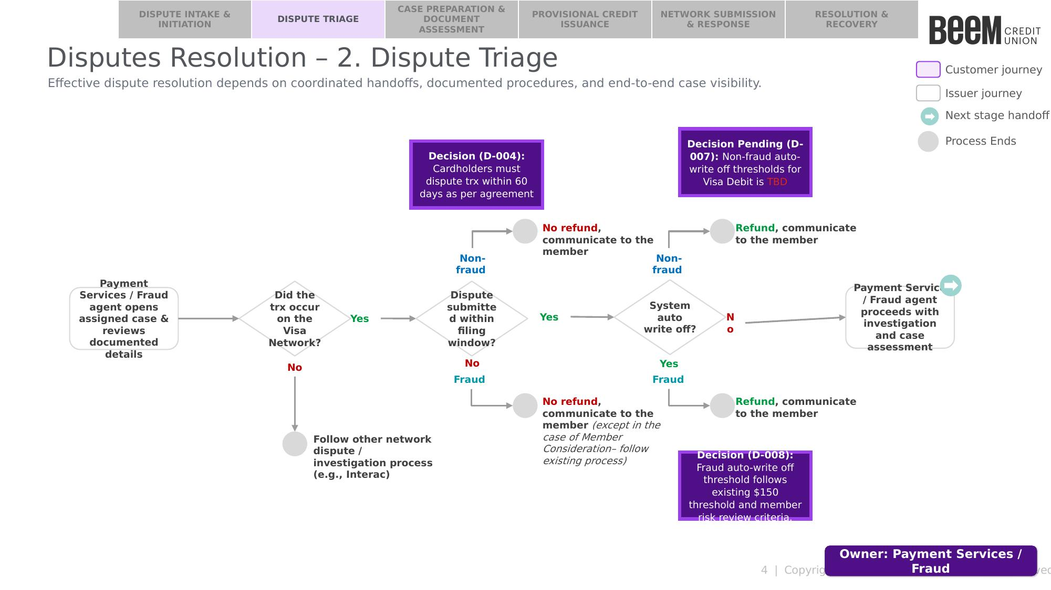

5.2 Procedure
The following procedure provides a step-by-step outline of the activities performed by the assigned Payment Services or Fraud agent as part of dispute triage.

5.2.1 Open the Case and Confirm Completeness
The assigned agent should:
- Open the assigned case and review the documented details received from Growth. [feedback: this isn’t a step this is just an intro sentence into the below which are steps of ‘reviewing’ the documented details]
- Confirm whether the disputed transaction occurred on the Visa Network. [feedback: we need to be more precise, in the Dispute Intake process we say that the Transaction Details within the CRM case will contain the network type, so lets make it clear for the fraud / payment services agent where to check]
  - If the transaction did not occur on the Visa Network: follow the applicable other network dispute / investigation process (e.g., Interac). This procedure ends.
  - If the transaction occurred on the Visa Network: proceed to the next step.
- Confirm the case documentation was completed correctly: [feedback: I think we need to make sure to be more precise, like checking if the dispute narrative / case details are actually fraud for fraud team or non fraud for non fraud team]
- Based on the case classification, proceed to the applicable section:
  - Fraud: proceed to Section 5.2.2 — Fraud Team: Assess Filing Window and Auto Write-Off.
  - Non-Fraud: proceed to Section 5.2.3 — Payment Services Team: Assess Filing Window and Auto Write-Off.

5.2.2 Fraud Team: Assess Filing Window and Auto Write-Off
Step 1 — Assess filing window: the Fraud Specialist should assess whether the dispute was submitted within the filing window.
Decision (D-004): cardholders must dispute a transaction within 60 days of the transaction date, as per agreement. [feedback: can we integrate this with the step 1 line above, and we don’t need to call out speicifcally that it’s a decision]
- If the dispute was not submitted within the filing window (i.e., outside the 60-day window from the transaction date): no refund, except in the case of Member Consideration (Beem’s goodwill refund) — follow the Fraud Reimbursement Guidelines to determine eligibility.
  - Document the rationale for the refund decision in the CRM case notes. [feedback: I almost think that if statements should be bullet circle points and the steps like this one should be numbered]
  - Close the case by setting the CRM case status to “Closed”, which routes the case back to the Growth team. This procedure ends. [feedback: should be numbered since it’s a sequential step]
- If the dispute was submitted within the filing window: proceed to Step 2 — Assess auto write-off.
Step 2 — Assess auto write-off: the Fraud Specialist should assess whether the dispute qualifies for a system auto write-off.
Decision (D-008): the fraud auto write-off threshold is $150. Disputes at or below this threshold, and meeting member risk review criteria, qualify for auto write-off. [feedback: same feedback as above]
- If the dispute amount is at or below $150 and meets the member risk review criteria: refund and communicate to the member.
  - Set the CRM case status to “Qualify for Auto-Write Off”, which routes the case back to the Growth team. This procedure ends.
- If the dispute amount is above $150, or does not meet the member risk review criteria: proceed with investigation and case assessment — see Stage 3A: Case Preparation & Document Assessment, and refer to the Visa Debit Card Fraud Investigation Process.

5.2.3 Payment Services Team: Assess Filing Window and Auto Write-Off
Step 1 — Assess filing window: the Payment Services agent should assess whether the dispute was submitted within the filing window.
Decision (D-004): cardholders must dispute a transaction within 60 days of the transaction date, as per agreement. . [feedback: same feedback as above]
- If the dispute was not submitted within the filing window (i.e., outside the 60-day window from the transaction date): no refund.
  - Document the rationale for the no-refund decision in the CRM case notes. [feedback: should be numbered]
  - Close the case by setting the CRM case status to “Closed”, which notifies the Growth team member who opened the case of the case closure. This procedure ends.
- If the dispute was submitted within the filing window: proceed to Step 2 — Assess auto write-off.
Step 2 — Assess auto write-off: the Payment Services agent should assess whether the dispute qualifies for a system auto write-off.
Decision Pending (D-007): the non-fraud auto write-off threshold for Visa Debit is TBD [X — placeholder]. [feedback: same as feedback earlier where this should not be a separate line item where its called a decision]
- If the dispute amount is at or below the threshold: refund and communicate to the member.[if statements should be bullet points]
  - Set the CRM case status to “Qualify for Auto-Write Off”, which routes the case back to the Growth team. This procedure ends.
- If the dispute amount is above the threshold: proceed with investigation and case assessment — see Stage 3A: Case Preparation & Document Assessment.

